

RECEIPT OF DRIVER’S SALARY

I **PIYUSH CHAUHAN** have received amount of ***Rs. 10000/-*** as my salary towards driving assistance

from Mr. ***MANVENDRA SINGH RAGHAVA*** for the month of **APRIL*, 2021***.

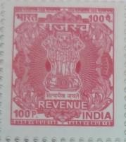

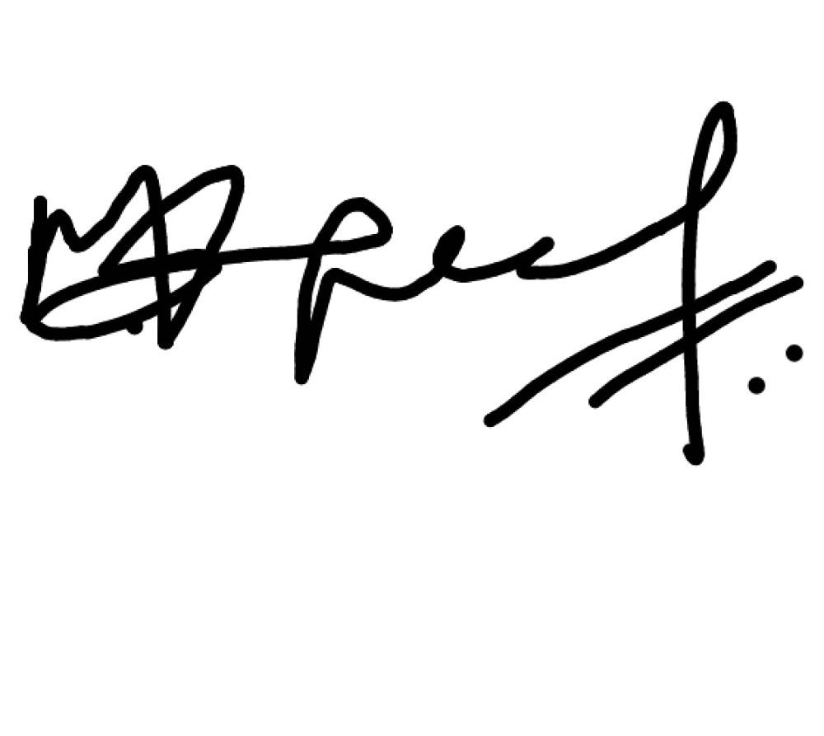**Signature of the Employee Signature of Driver**

**Name of Employee** - MANVENDRA SINGH **Name of Driver -** Piyush chauhan

**Employee Code** - 3153514 **Date –** APR 1, 2021

***Note:***

1. *The employee can claim the Driving Assistance Expenses only “ONE” vehicle under Driving Assistance Expenses head.*
2. *The Vehicle must be in the name of employee only for which the Driving Assistance Expenses is being claimed.*
3. *Employee should have incurred expense towards Driving Assistance for claiming these benefit as a set off from their Special Allowance and get the benefit of Tax rebate.*

**Confidential Page 1 Driver Salary**